

**MG209 Assignment:**

**Corporate Structure: New World Trading**

*Portfolio of Findings*

**Lewis Britton {201724452}**

MG209: Organisational Analysis & Strategy

November 2018

Word Count: {2493}

**Source 1 – Formation of New World Trading Co.**

*News Article – The Morning Advisor*

**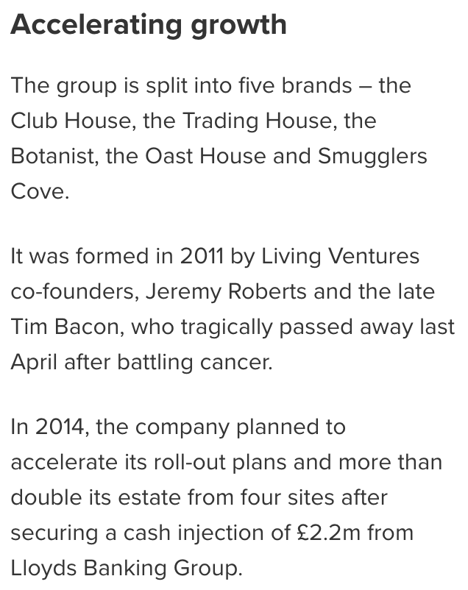***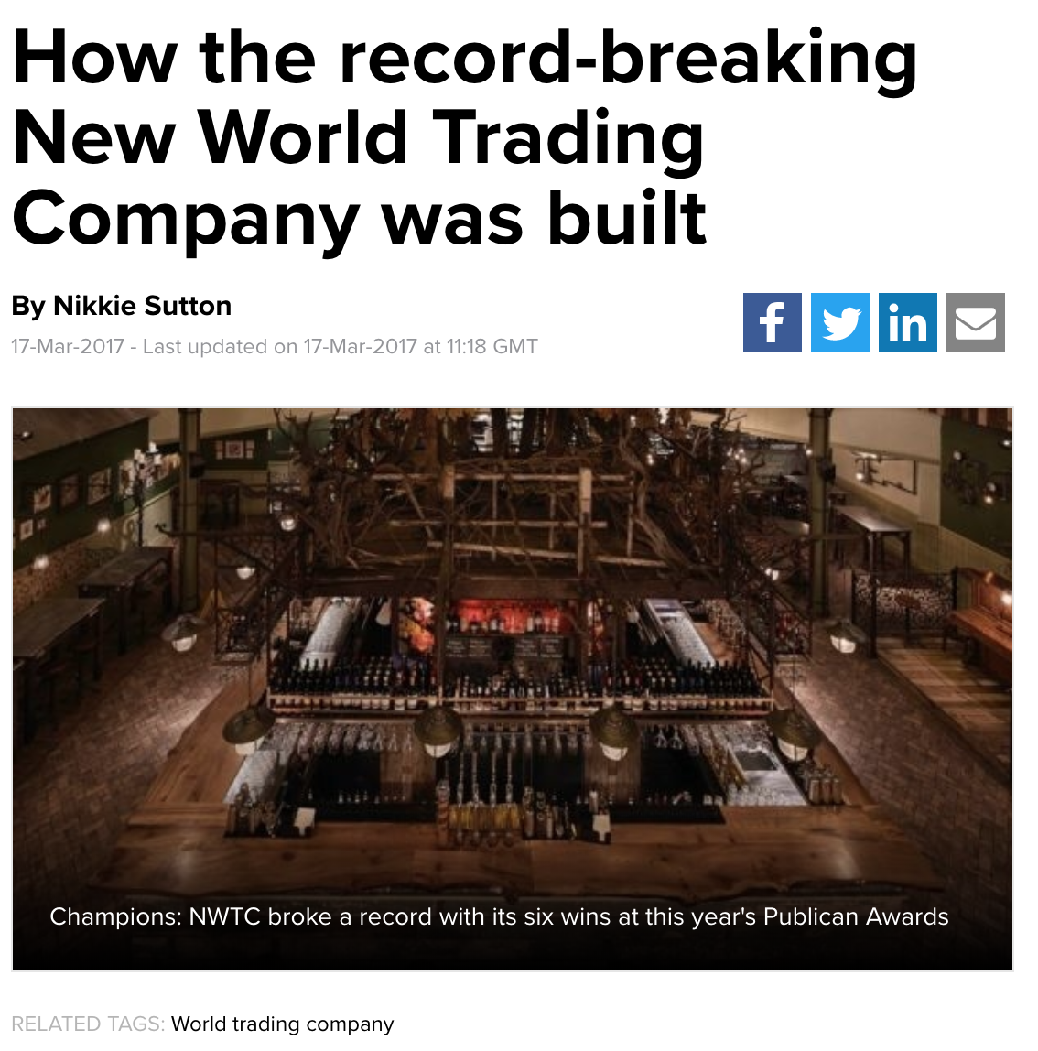*

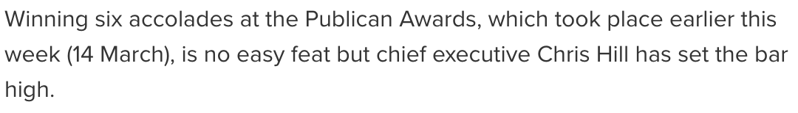

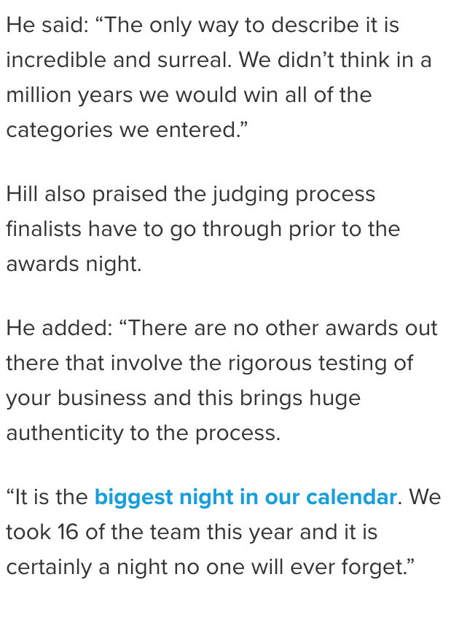

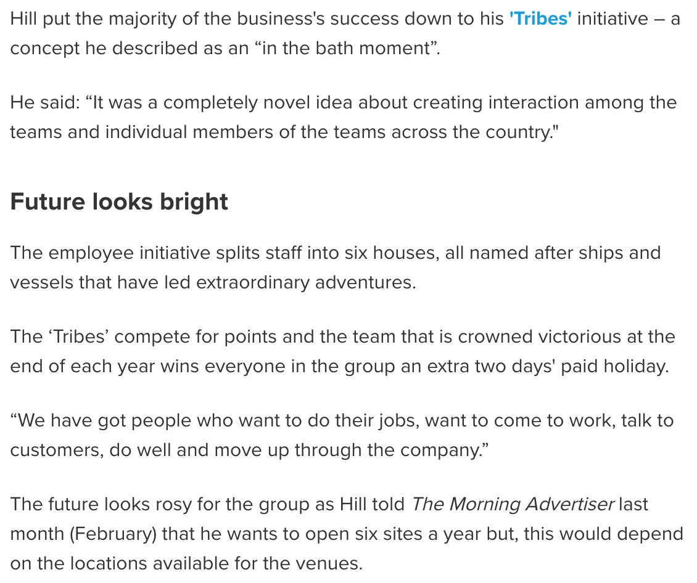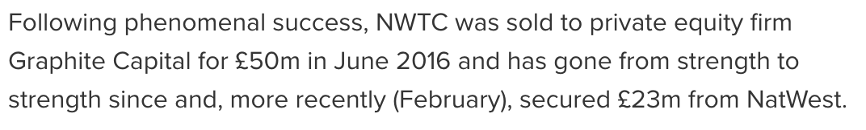

*\*Please Note: .html text formatting was unavailable on this site. Hence, the screenshotted text*

***From:*** Nikkie Sutton (2017). *How the Record-Breaking New World Trading Co. Was Built*. Found At: https://www.morningadvertiser.co.uk/Article/2017/03/17/How-the-record-breaking-New-World-Trading-Company-was-built# Accessed: Throughout October & November 2018

**Source 2 – Post-Investment Growth & Re-Structuring**

*News Article – The Morning Advisor*

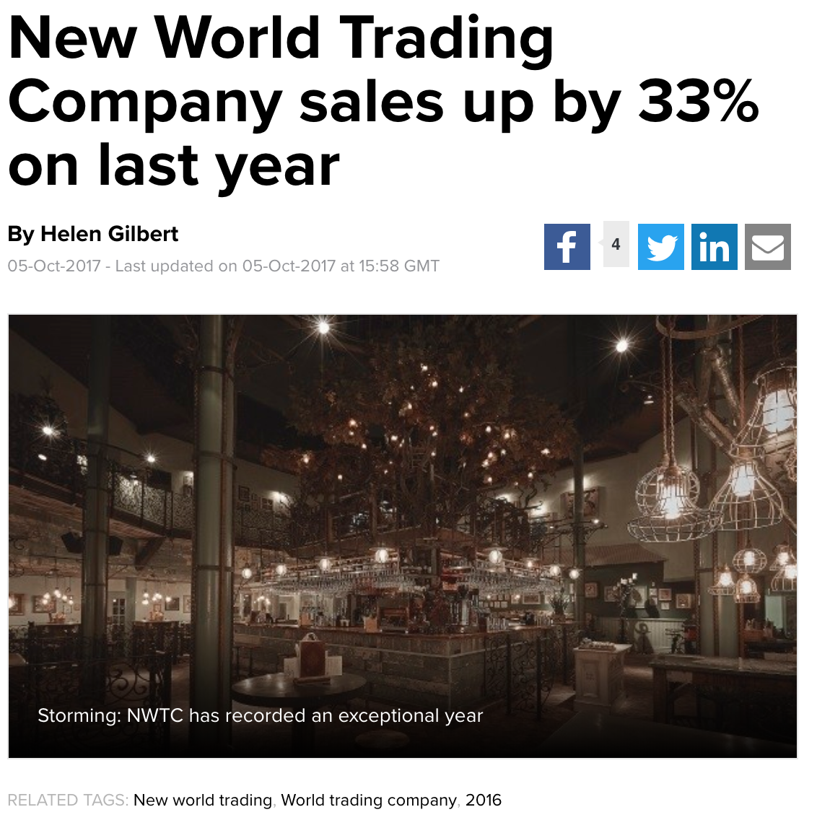

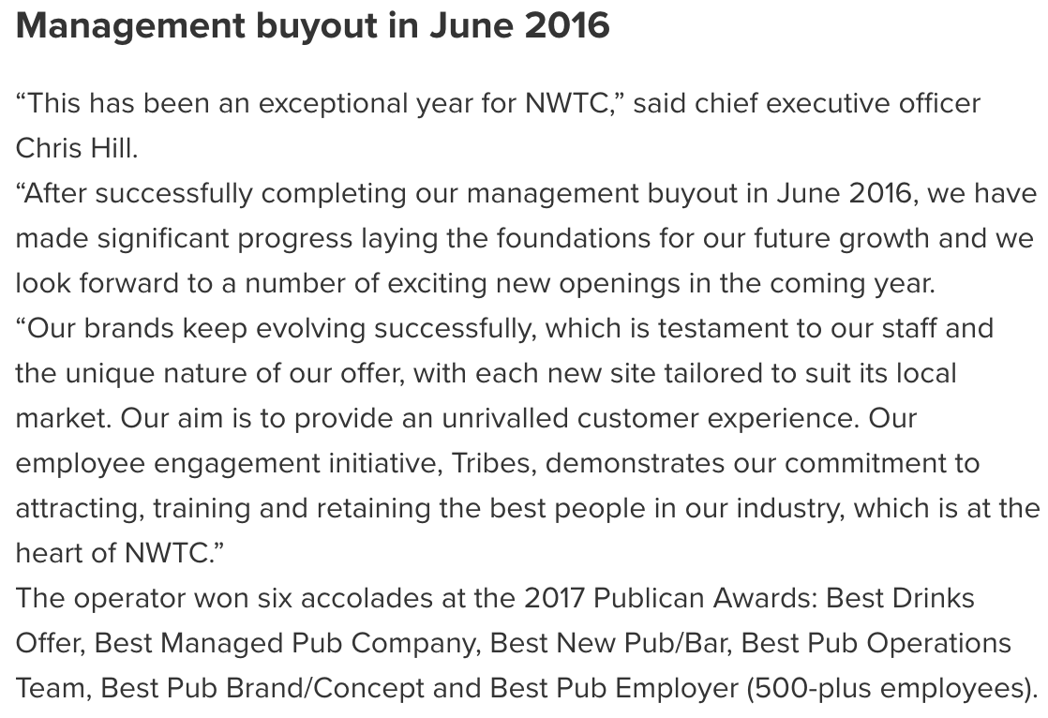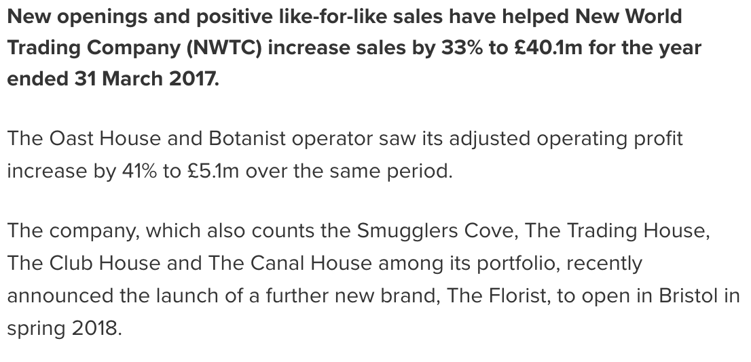

*\*Please Note: .html text formatting was unavailable on this site. Hence, the screenshotted text*

***From:*** Helen Gilbert (2017). *New World Trading Company Sales Up By 33% on Last Year.* Found At: https://www.morningadvertiser.co.uk/Article/2017/10/05/New-World-Trading-Company-sales-up-by-33-to-40.1m-on-last-year Accessed: Throughout October & November 2018

**Source 2 – Employee Reviews**

*Public Forums - Indeed*

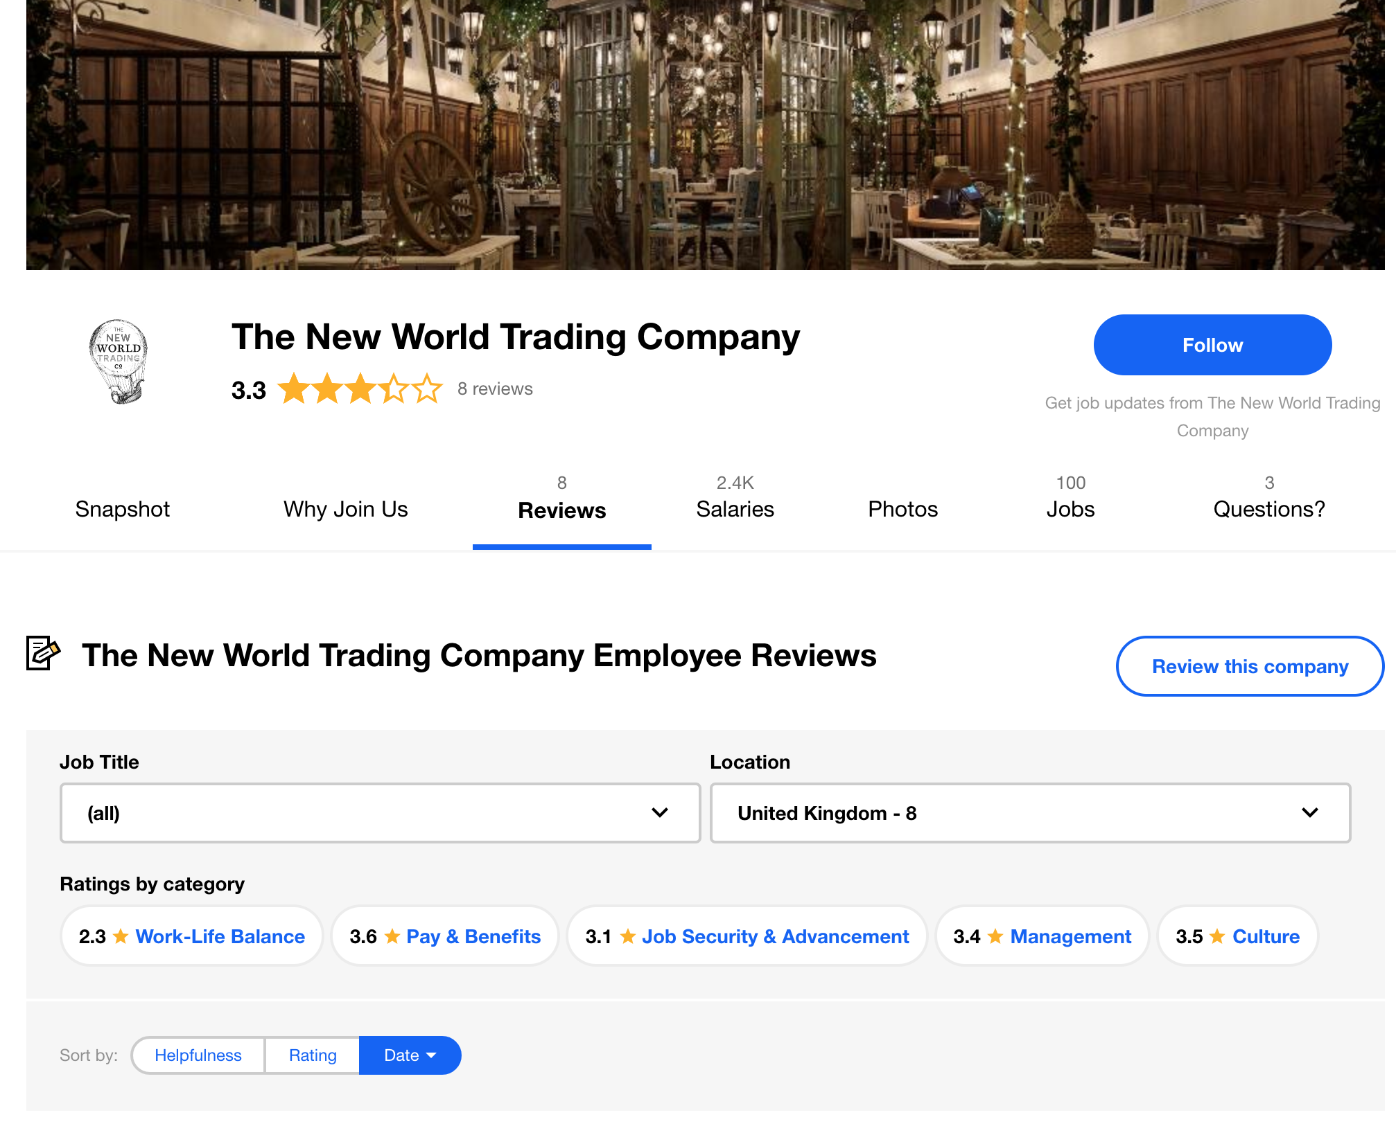

*\*A large array of individually written examples follows*

***From:*** *The New World Trading Company, Indeed* (2018). Found At: https://www.indeed.co.uk/cmp/The-New-World-Trading-Company/reviews Accessed: Throughout October & November 2018

**Source 4 – Gender Pay Gap**

*Statistical Analysis – New World Trading Co.*

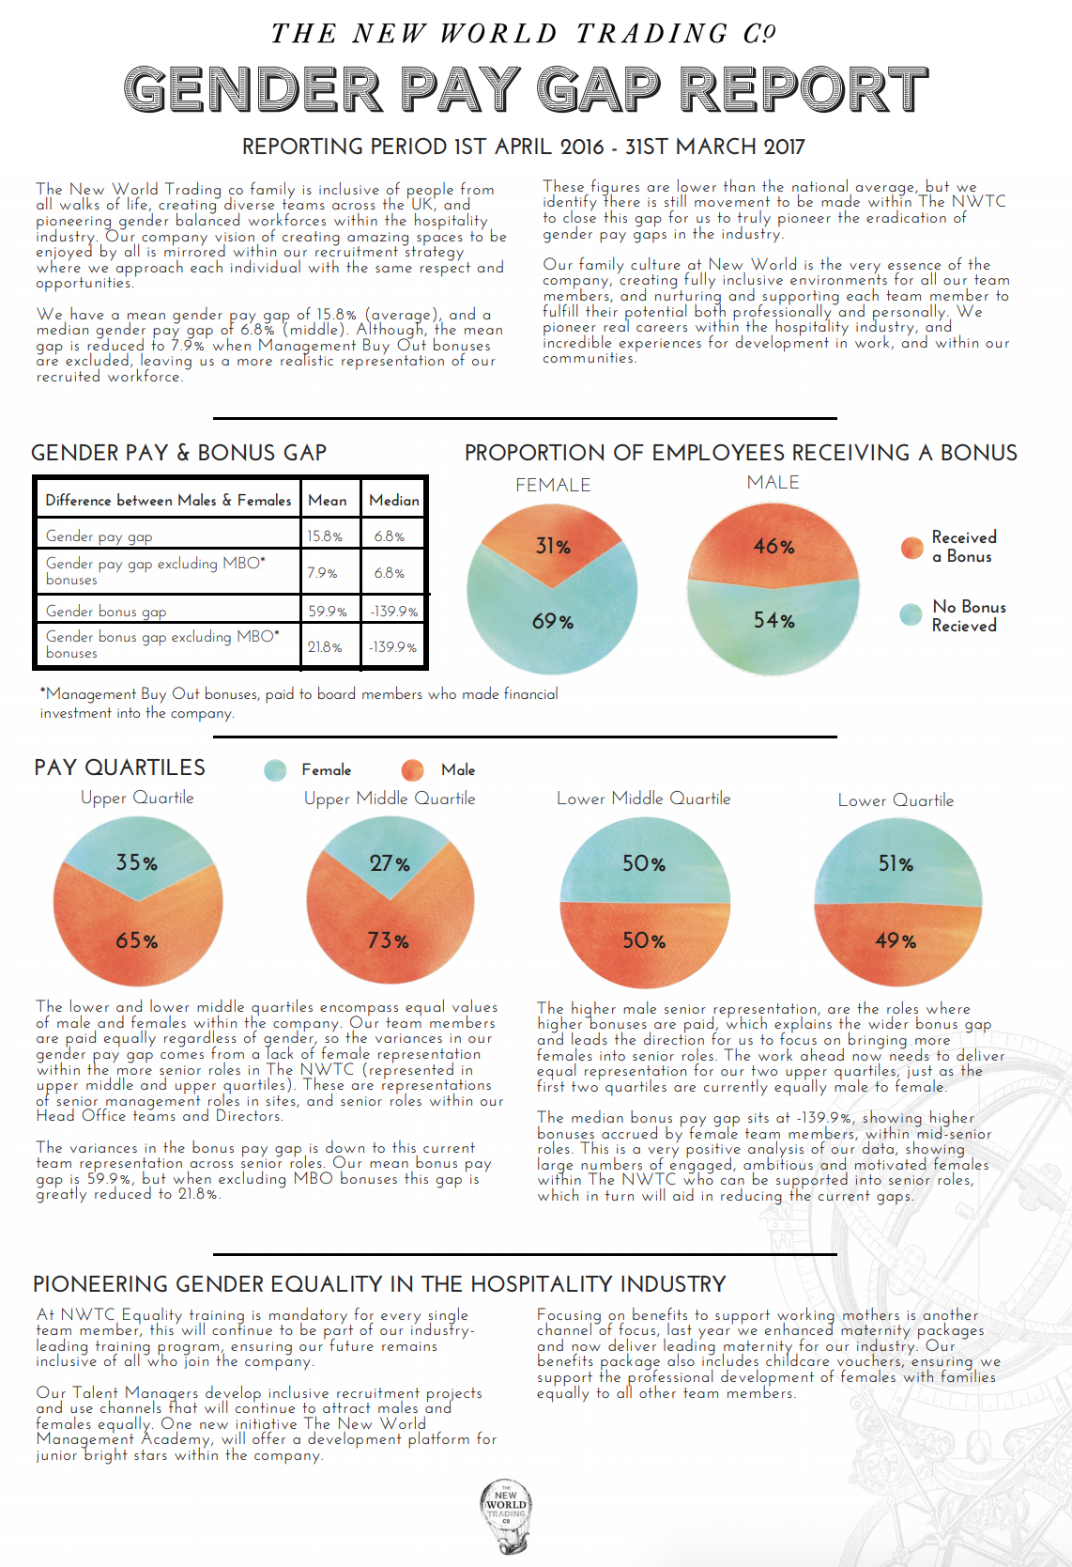

***From:*** *The New World Trading Co.* (2018). Found At: https://nwtc.uk.com/ Accessed: Throughout October & November 2018

**Source 5 – National Gender Pay Gap**

*News Article – The Guardian*

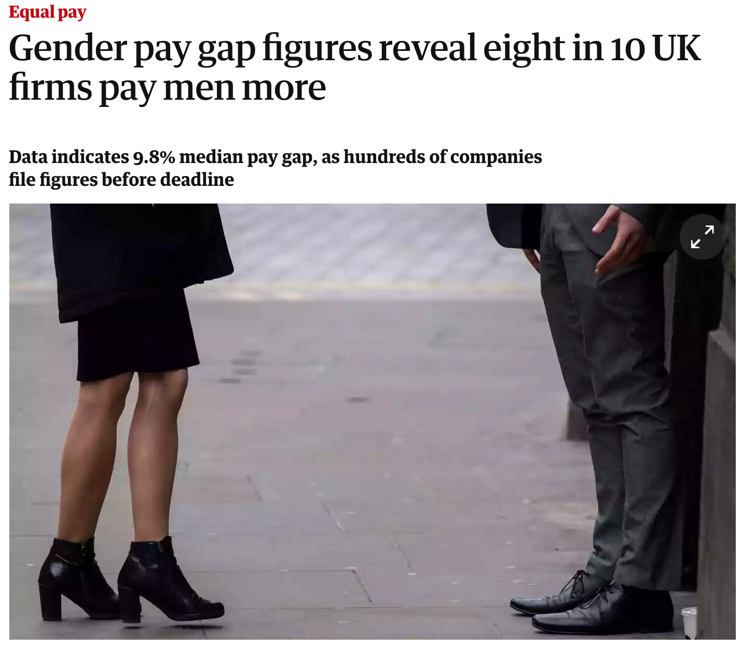

***From:*** Alexandra Topping, Caelainn Barr & Pamela Duncan (2018). *Gender Pay Gap Figures Reveal Eight in 10 UK Firms Pay Men More, The Guardian*. Found At: https://www.theguardian.com/money/2018/apr/04/gender-pay-gap-figures-reveal-eight-in-10-uk-firms-pay-men-more Accessed: October & November 2018

**Source 6 – 2018 Strategic Repot (Financial Statements 2018)**

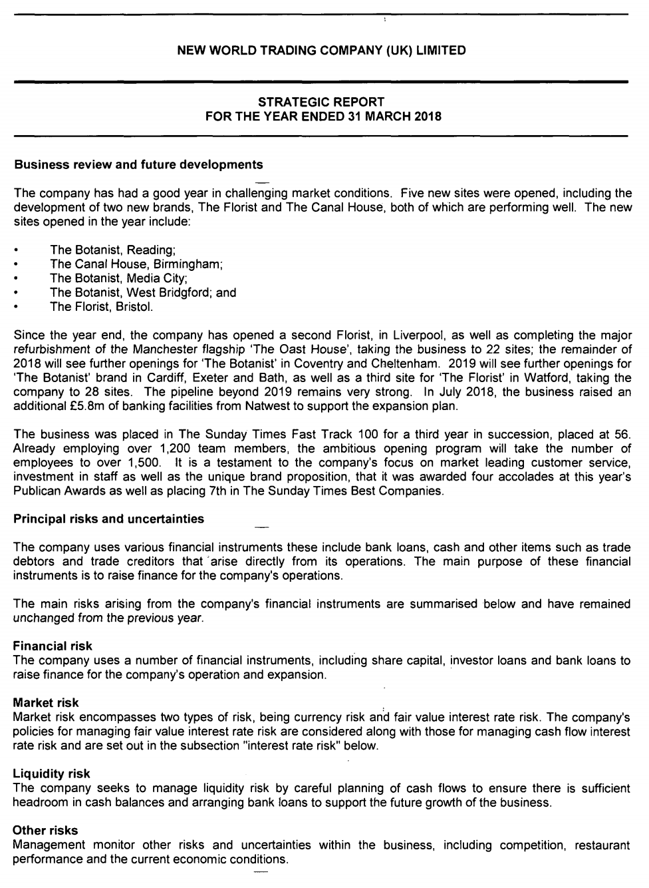

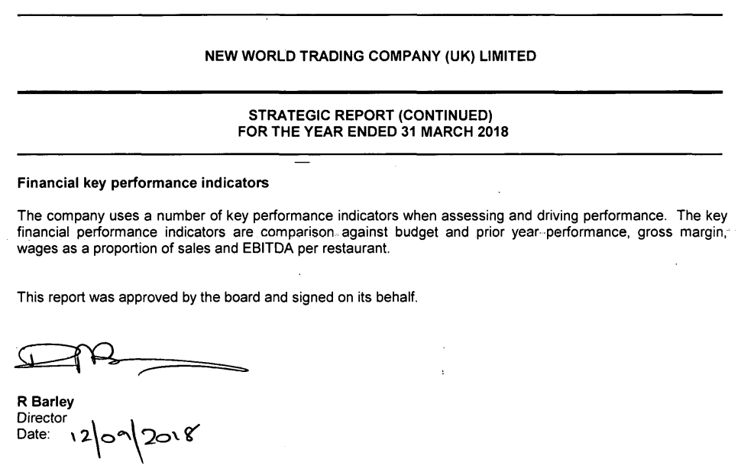

***From:*** *New World Trading Company (UK) Limited* (2018). Found At: https://beta.companieshouse.gov.uk/company/07685158/filing-history Accessed: October & November 2018

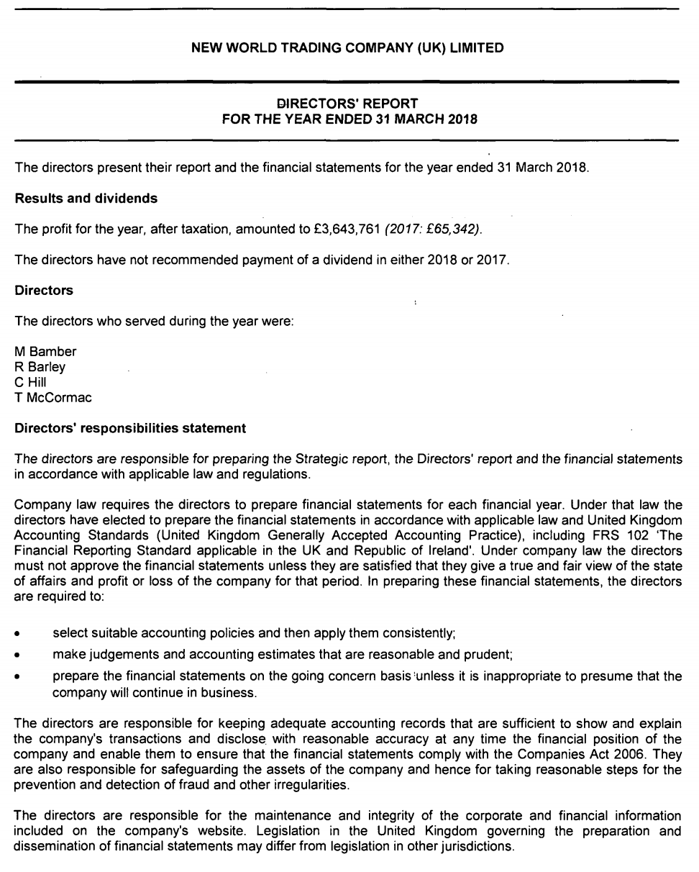**Source 7 – 2018 Director’s Report (Financial Statements 2018)**

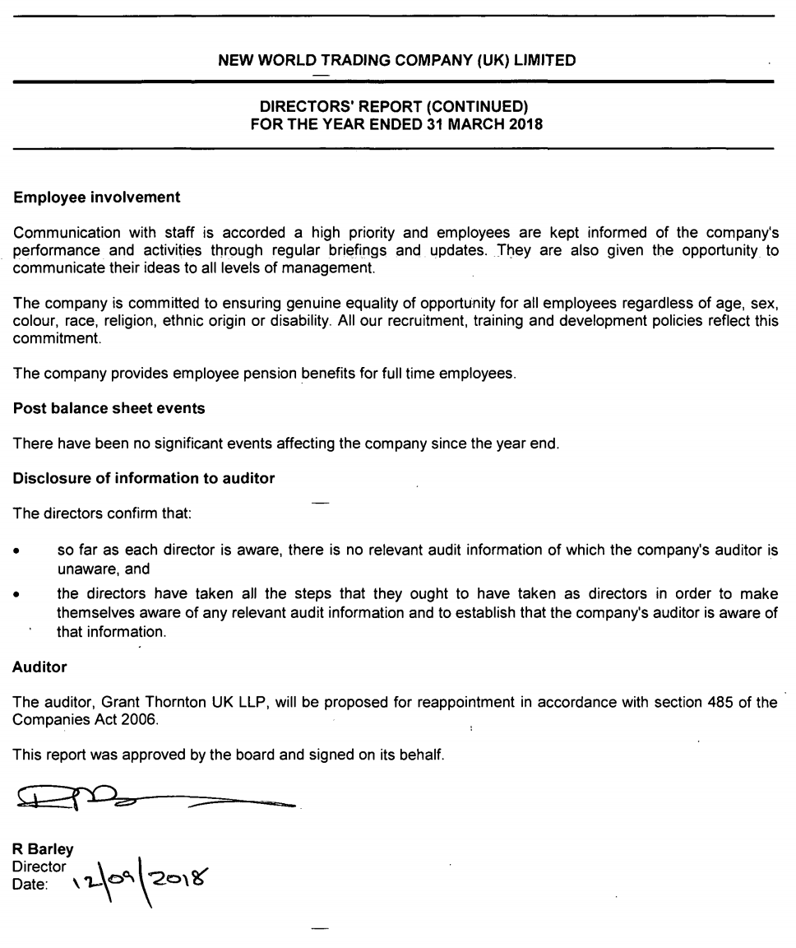

***From:*** *New World Trading Company (UK) Limited* (2018). Found At: https://beta.companieshouse.gov.uk/company/07685158/filing-history Accessed: October & November 2018

**Source 8 – 2018 Income Statement (Financial Statements 2018)**

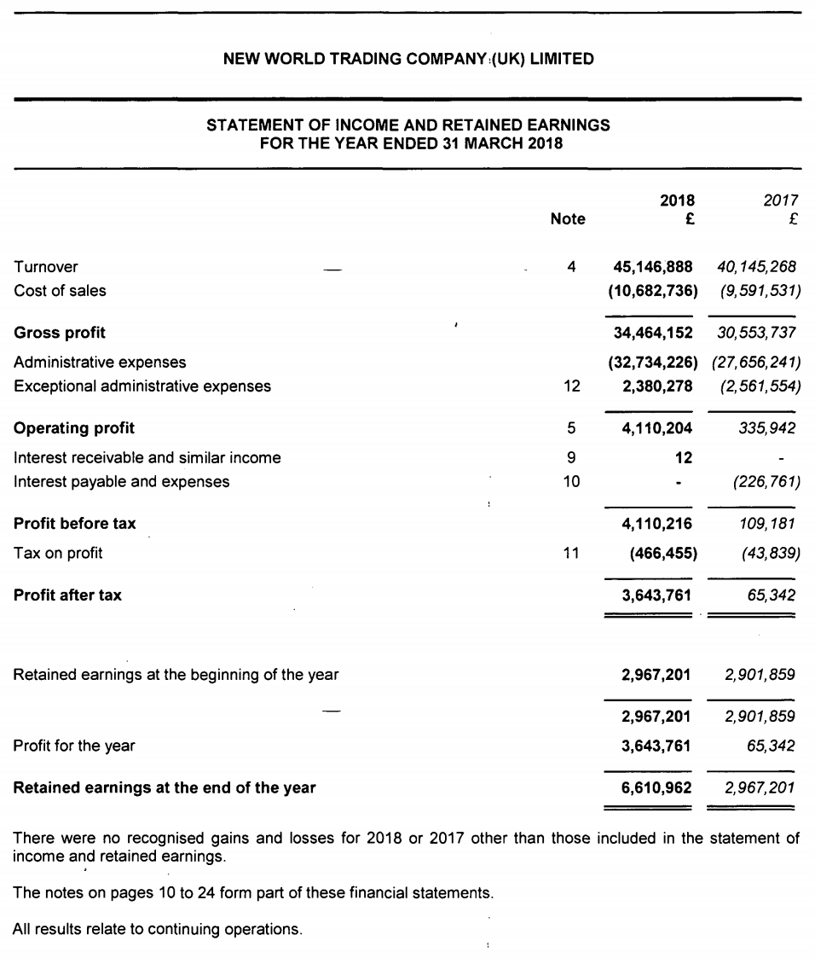

***From:*** *New World Trading Company (UK) Limited* (2018). Found At: https://beta.companieshouse.gov.uk/company/07685158/filing-history Accessed: October & November 2018

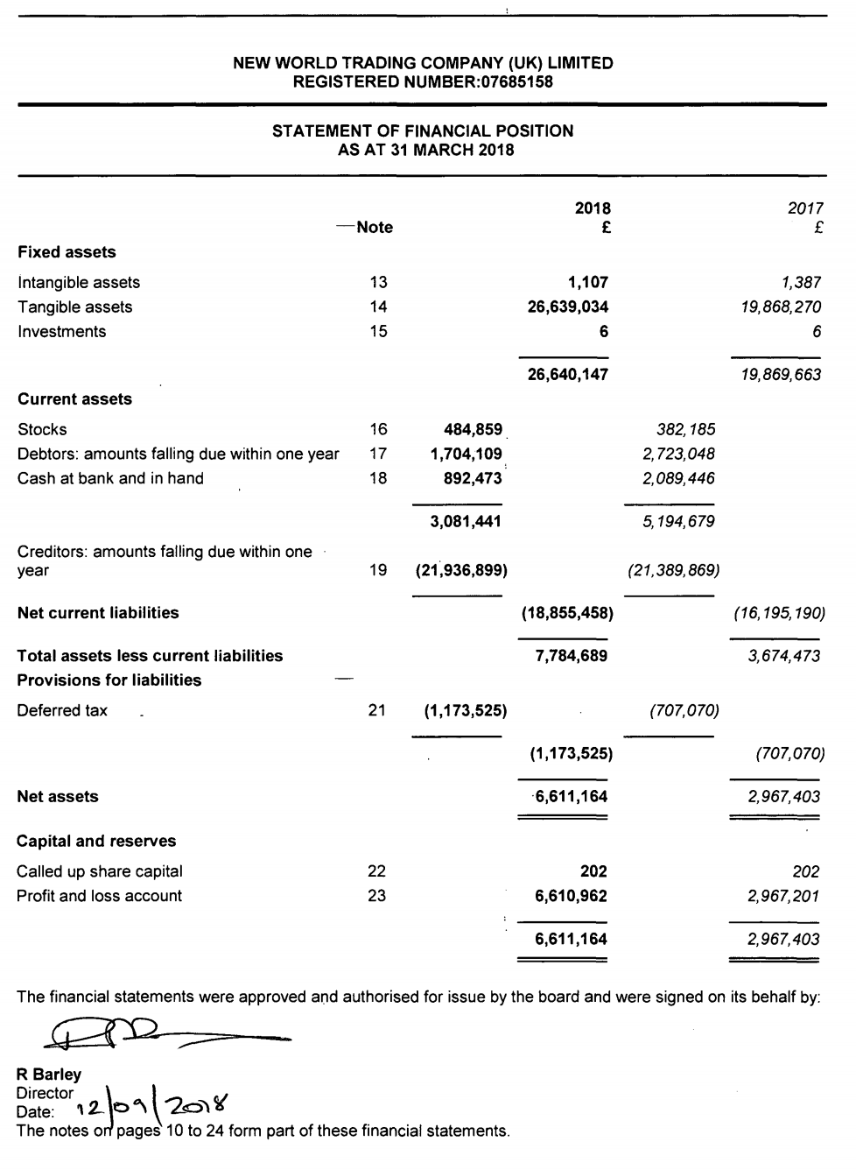**Source 9 – 2018 Balance Sheet (Financial Statements 2018)**

***From:*** *New World Trading Company (UK) Limited* (2018). Found At: https://beta.companieshouse.gov.uk/company/07685158/filing-history Accessed: October & November 2018

**Source 10 – 2018 Notes to Financial Statement (Financial Statements 2018)**

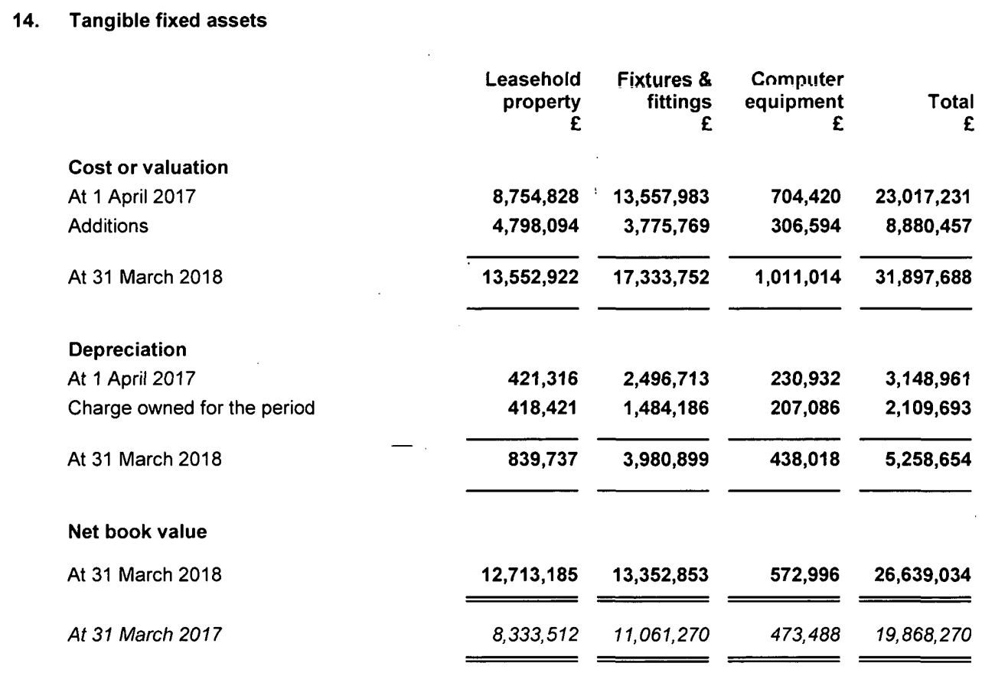

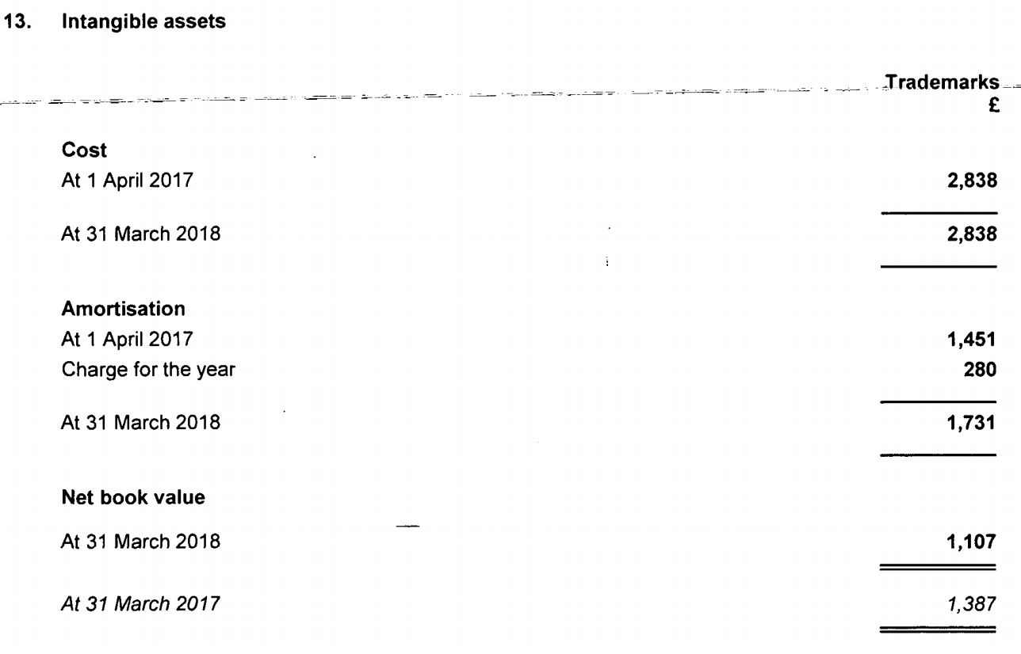

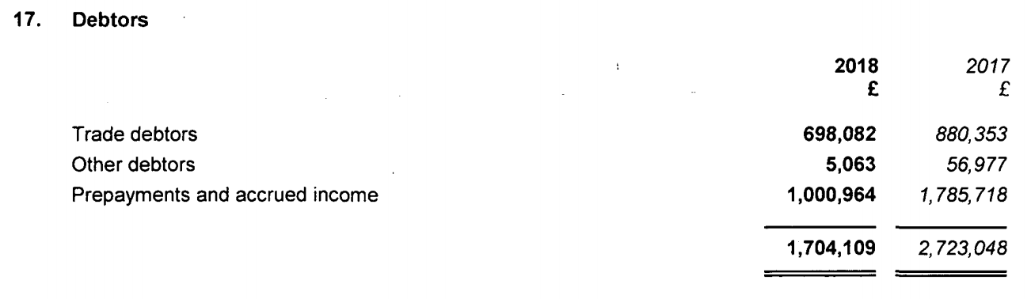

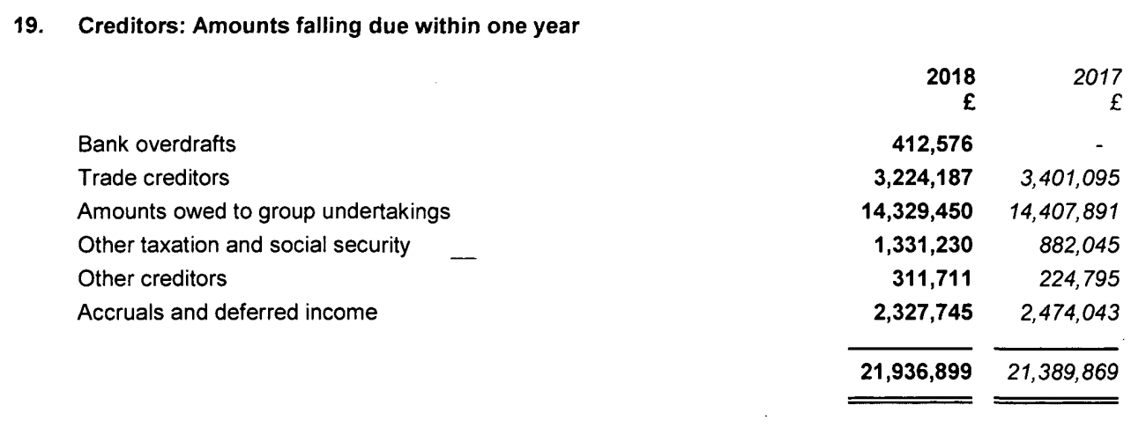

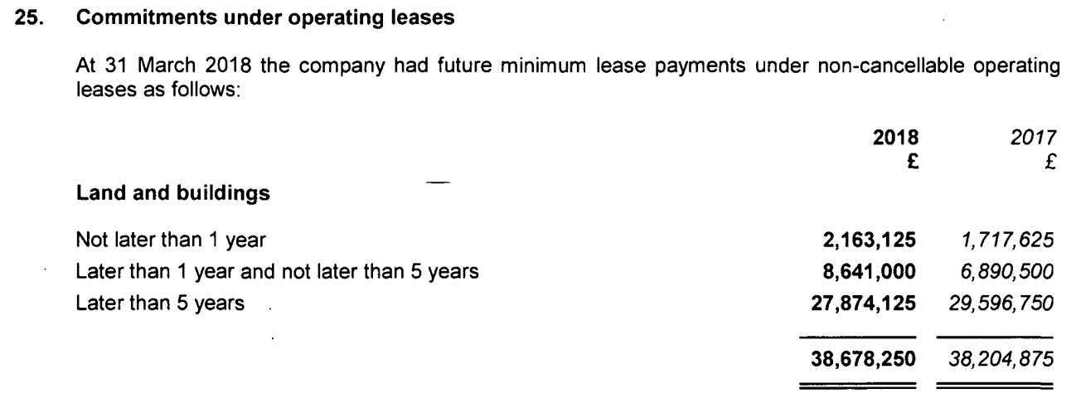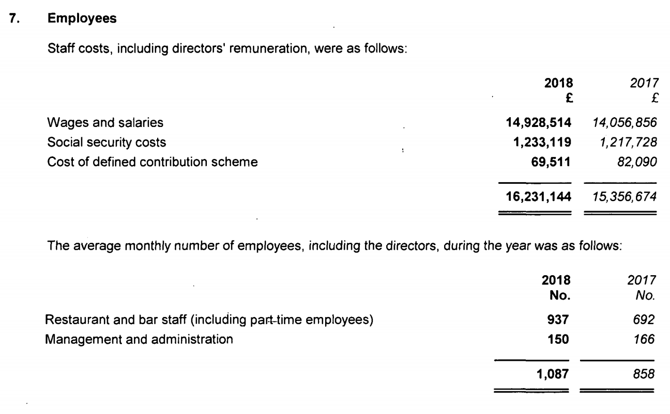

***From:*** *New World Trading Company (UK) Limited* (2018). Found At: https://beta.companieshouse.gov.uk/company/07685158/filing-history Accessed: October & November 2018

**Source 11 – 2014 Strategic Repot (Financial Statements 2014)**

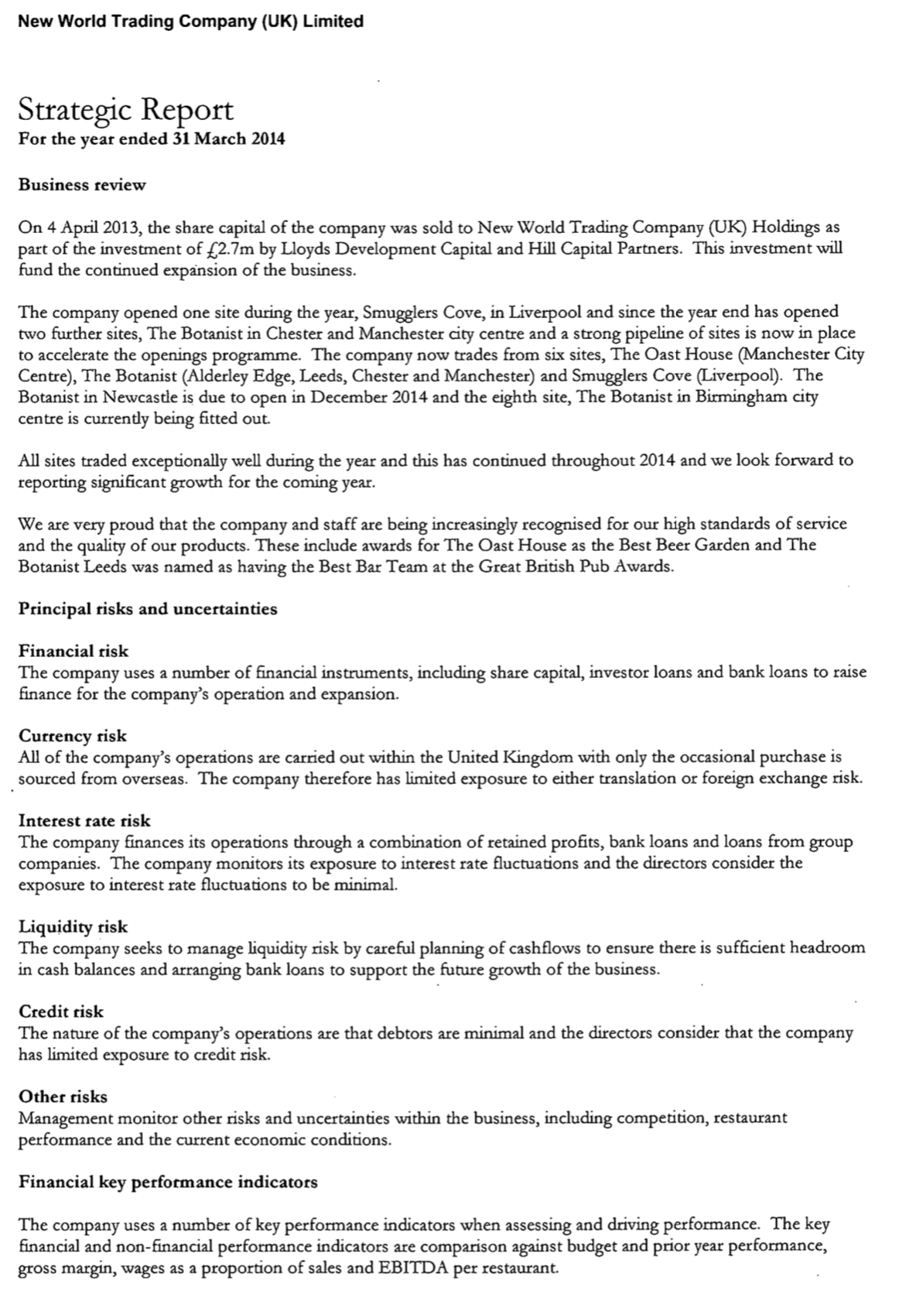

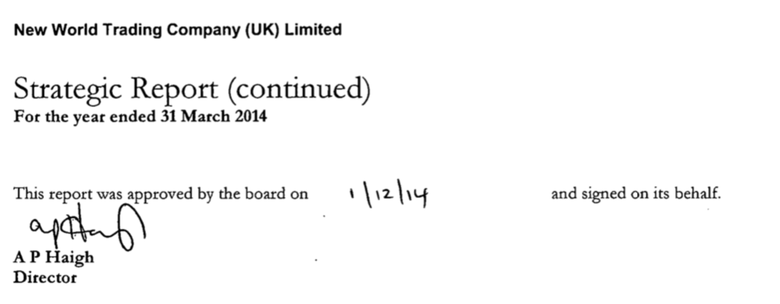

***From:*** *New World Trading Company (UK) Limited* (2018). Found At: https://beta.companieshouse.gov.uk/company/07685158/filing-history Accessed: October & November 2018

**Source 12 – 2014 Director’s Report (Financial Statements 2014)**

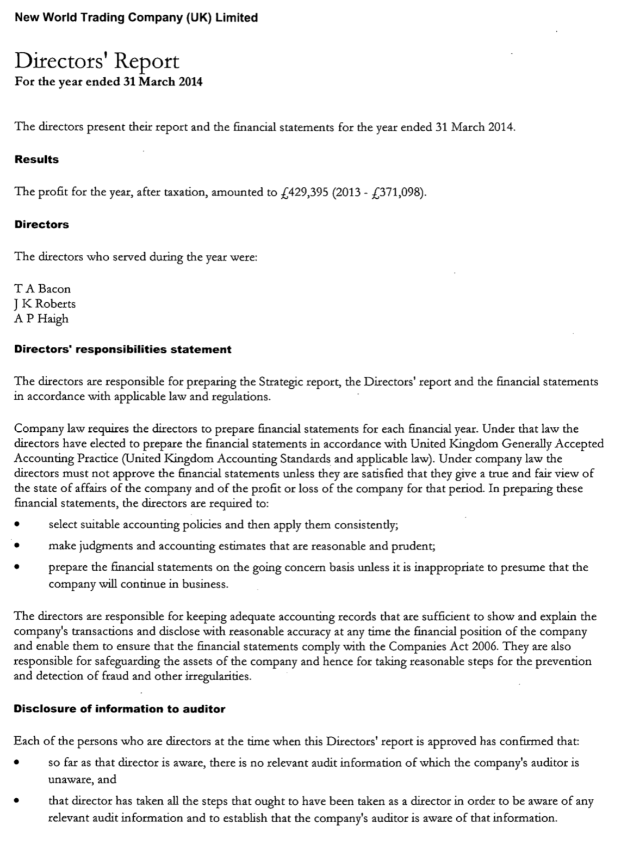

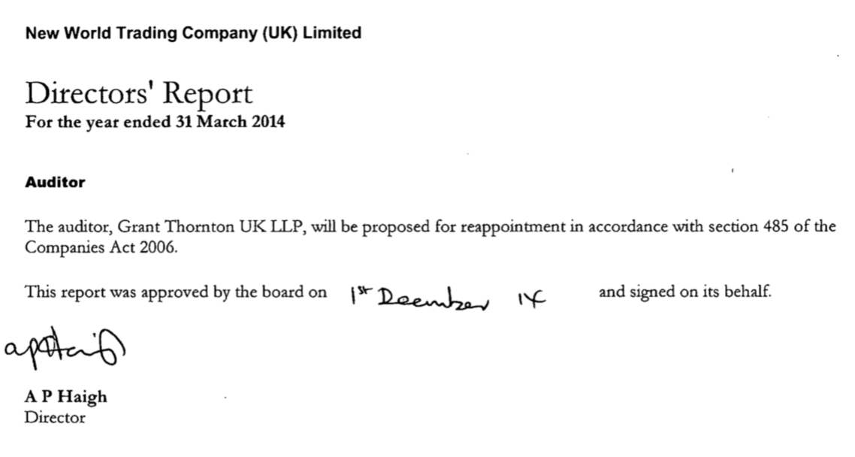

***From:*** *New World Trading Company (UK) Limited* (2018). Found At: https://beta.companieshouse.gov.uk/company/07685158/filing-history Accessed: October & November 2018

**Source 13 – 2014 Income Statement (Financial Statements 2014)**

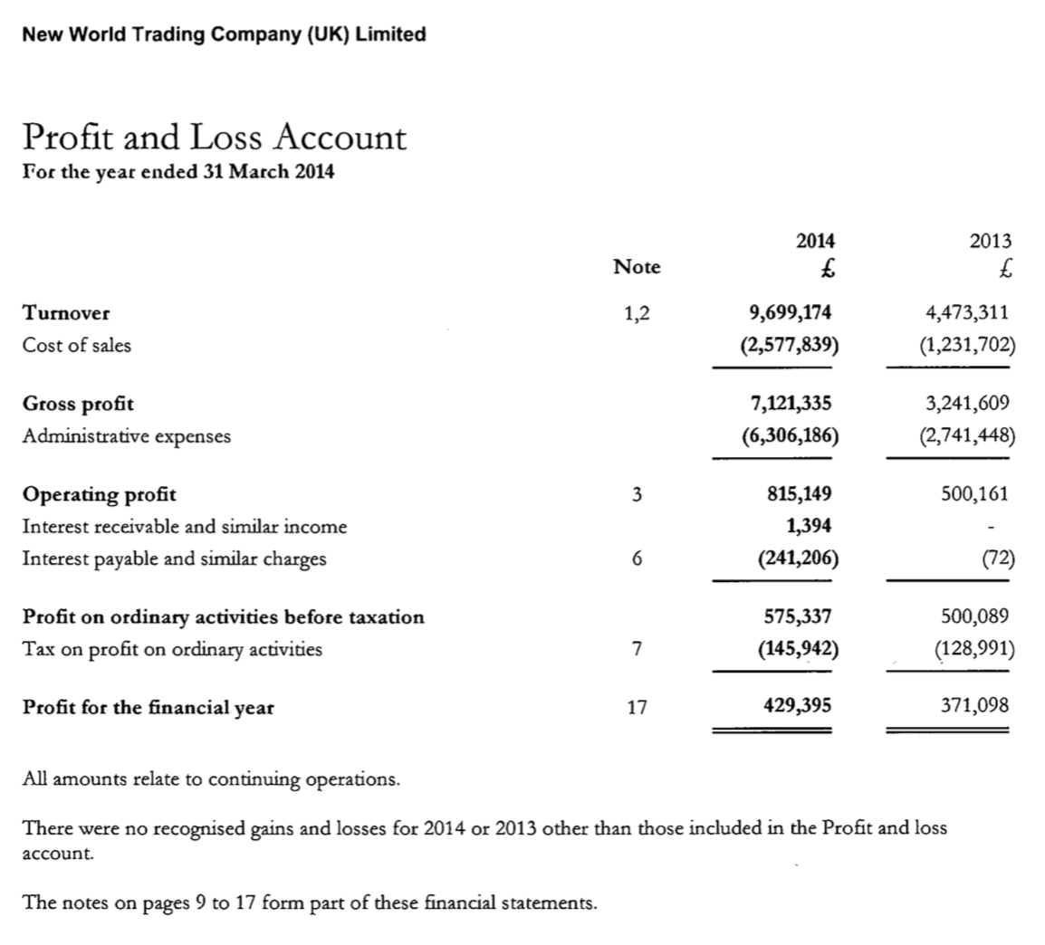

***From:*** *New World Trading Company (UK) Limited* (2018). Found At: https://beta.companieshouse.gov.uk/company/07685158/filing-history Accessed: October & November 2018

**Source 14 – 2014 Balance Sheet (Financial Statements 2014)**

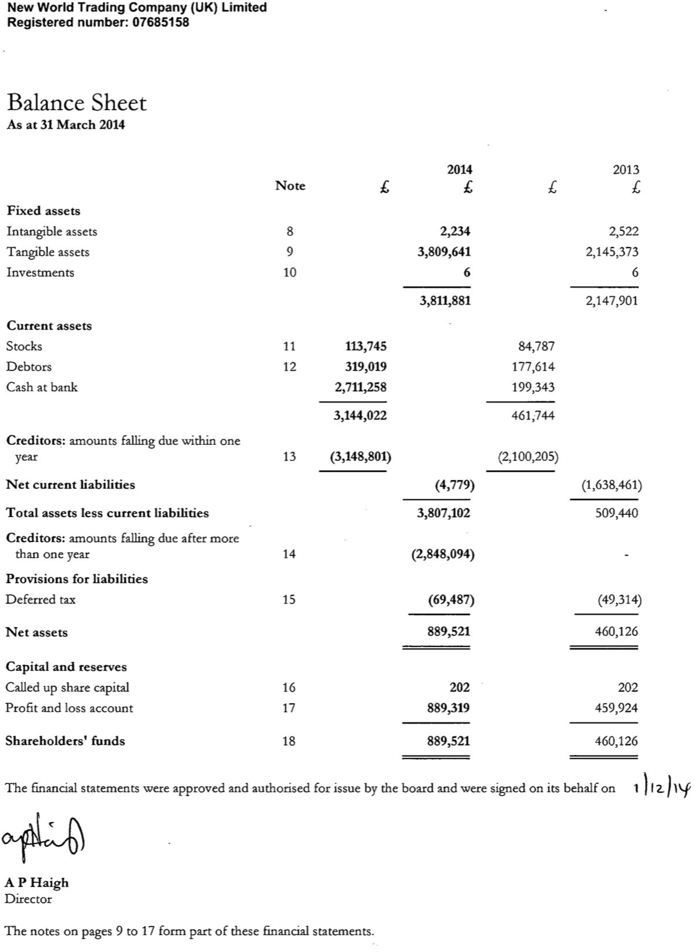

***From:*** *New World Trading Company (UK) Limited* (2018). Found At: https://beta.companieshouse.gov.uk/company/07685158/filing-history Accessed: October & November 2018

**Source 15 – 2014 Notes to Financial Statement (Financial Statements 2014)**

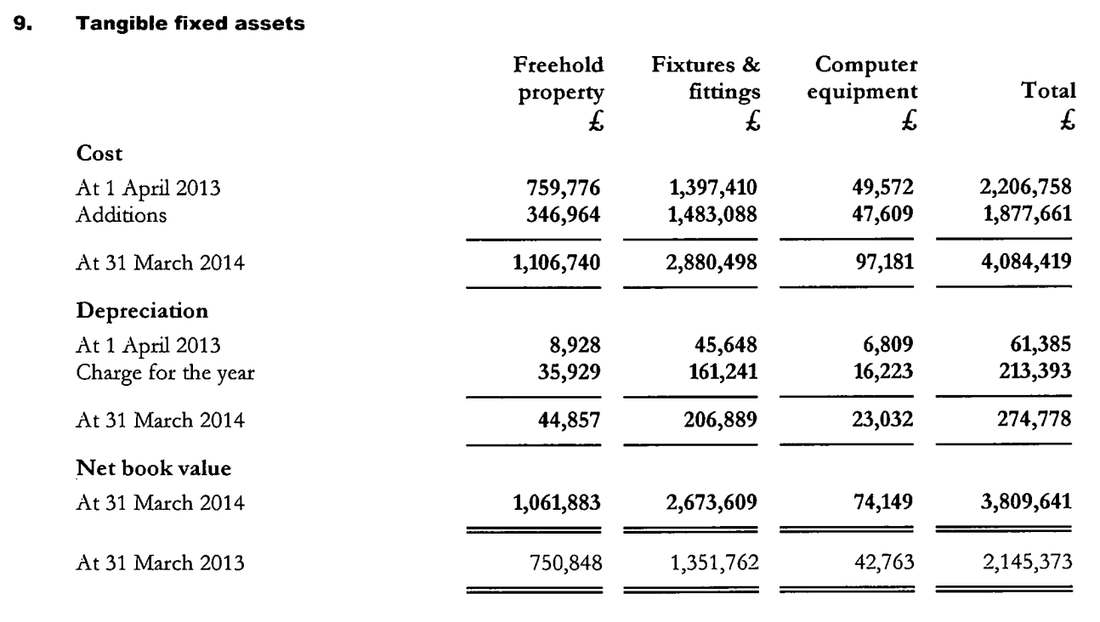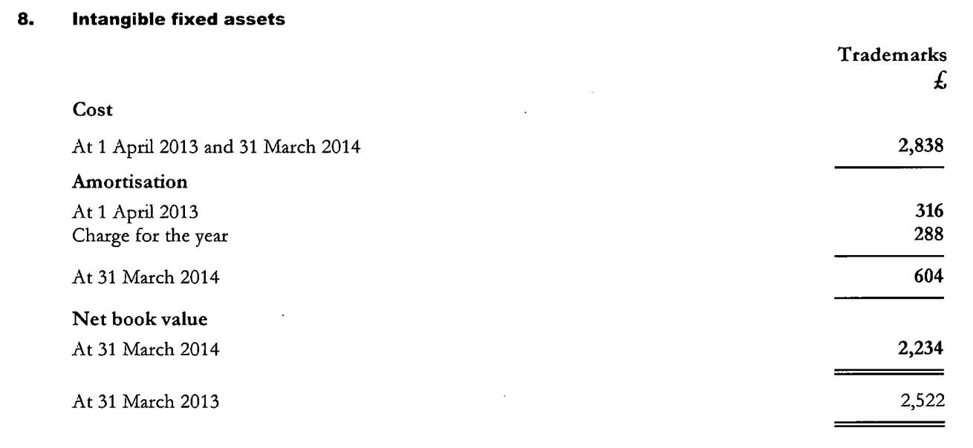

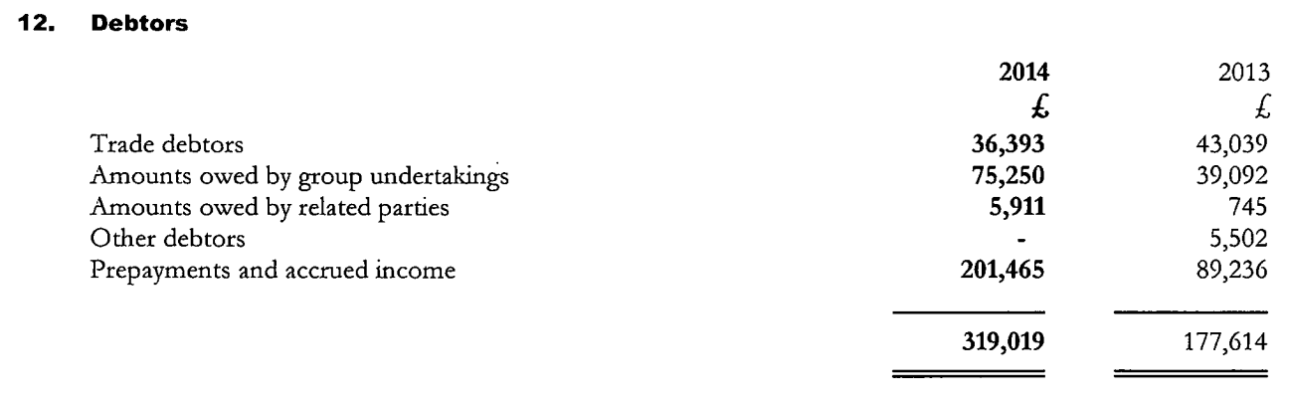

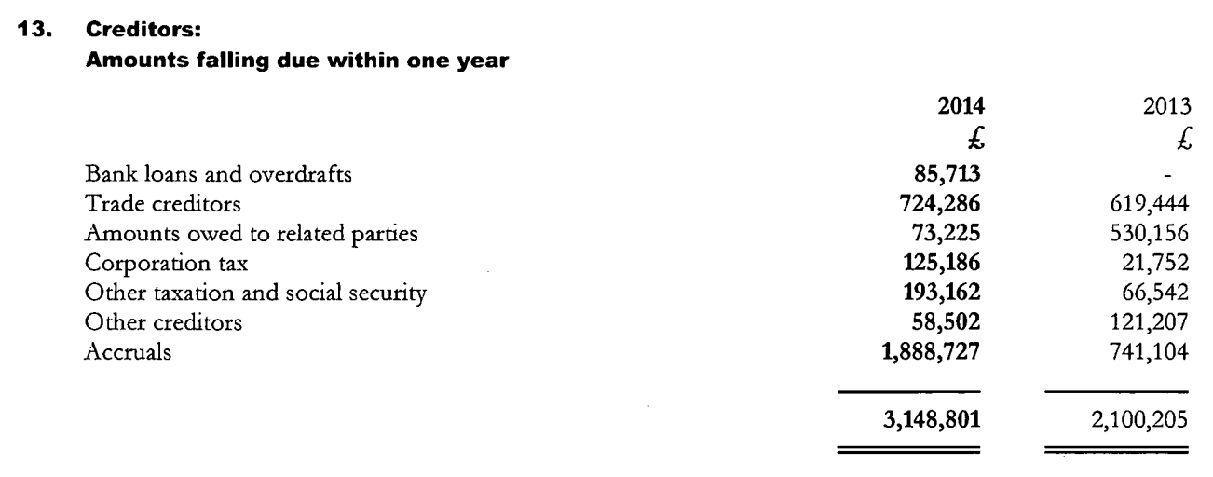

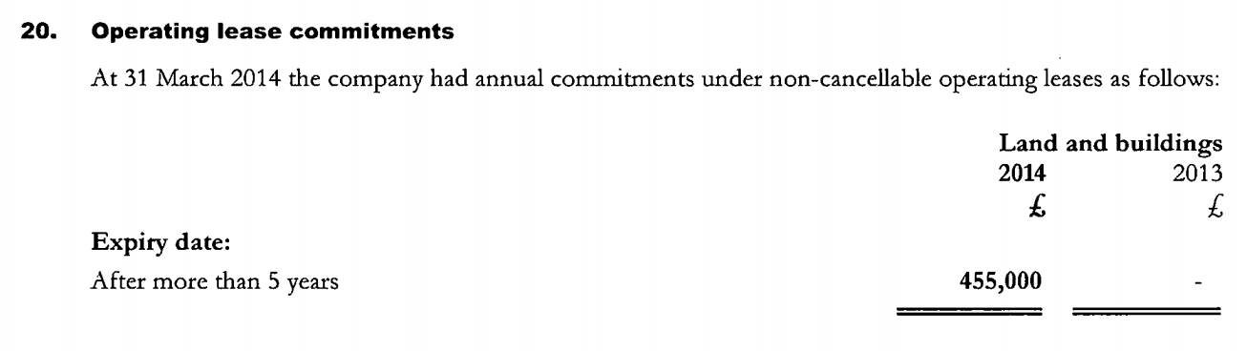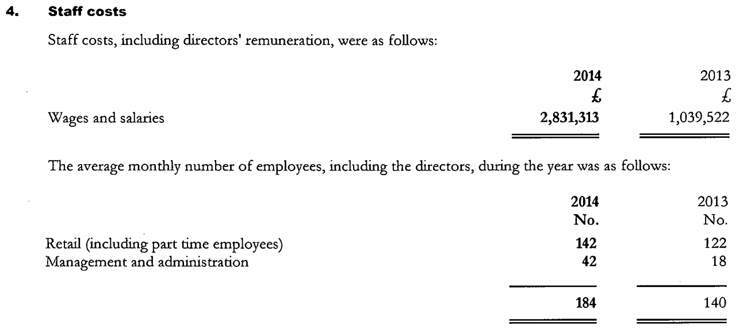

***From:*** *New World Trading Company (UK) Limited* (2018). Found At: https://beta.companieshouse.gov.uk/company/07685158/filing-history Accessed: October & November 2018